Published by | Editor

HEWI
Marketing + Innovation

HEWI Heinrich Wilke GmbH
P.O. box 1260
D-34442 Bad Arolsen
Phone: +49 5691 82-0
presse@hewi.de
www.hewi.com

Reprint free - specimen copy requested

System 111
Matt edition
Five decades as a design icon System 111 – this is what HEWI celebrated with an anniversary edition of this classic architecture product. Selected colours and a matt surface show how modern System 111 is. This new interpretation not only stands out from an optical point of view, it is also extremely pleasant to the touch.
The choice of materials has a decisive influence on spatial effect and style. System 111 in matt edition matt offers an interesting contrast between practicality and sensuality. Perfect deep black, deep white or discreet anthracite-grey create a new look in the matt finish.
HEWI stands for diversity: System 111 in the matt edition matt is available both in the classic variant and also in combination with mini and bicolor. In bicolor the matt polyamide surface meets stainless steel and metallic finishes in PVD. The matt finish roses emphasise the velvety look and feel of the door lever handle, and high-gloss surfaces create an interesting contrast. The reduced size and shape of the rose in the minim variant allows the door lever handle to become a style-defining element.
The HEWI-typical modular principle is also reflected in the matt edition of the System 111. The extensive range is rounded off with matching door bands, doorstops and window handles with a matt surface.

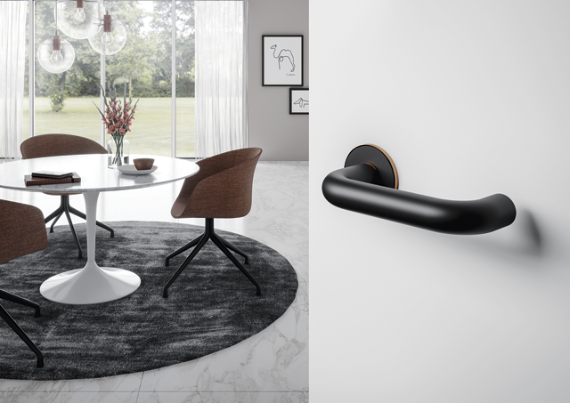
Re-edition System 111 | Edition matt in bicolor version

